
Griot International LLC

Helping You Share Your Thoughts with the World!
www.ighouse.com * (888) 600-2011
Custom Art Commission Contract

Contact Us:
Website:igphouse.com Email: info@griotinternational.com
(888) 600-2011

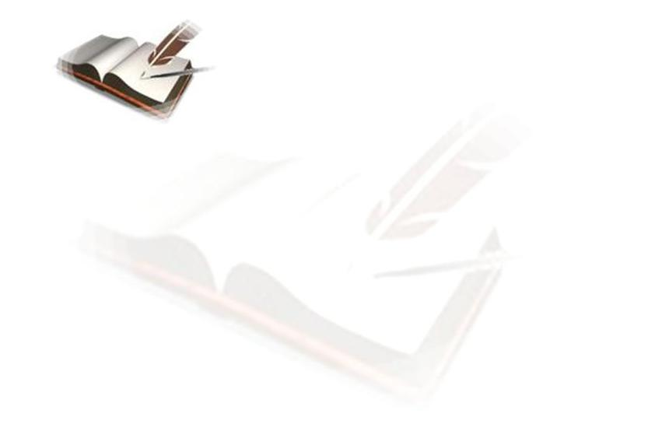
  This contract is entered into on the__________ of ________, _______, between GRIOT INTERNATIONAL LLC (hereinafter known as "Buyer") located at 19920 N. 23rd Ave. Phoenix AZ 85027 and____________________(hereinafter known as "Author") of _______________________________located at _______________________________concerning a work presently known as ___________________________ (hereinafter known as "Work").
  This Contract is considered legal and binding in all countries. If there should be any legal dispute, the laws of the state of Arizona shall apply.
  I. The Artist hereby represents and warrants to the Buyer that:
  A. The Artwork is free and clear of any counts of libel, plagiarism, breach of privacy or misrepresentation of facts.
  B. The Artwork does not infringe upon any copyright or proprietary right, common law or statutory law, and does not contain any material of libelous nature.
  C. The Artwork is not in the public domain and the Artist is the sole creator and copyright holder of the work with full power to enter into this contract.
  D. If the Artwork has been previously published in whole or part, the Artist currently holds all copyrights to the Artwork and is legally permitted to enter this agreement.
  E. The Artist releases the Buyer from any responsibilities relating to any legal actions incurred by the contents of the Artwork or the Artist.
  This representations contained herein are true on the date of the signing of this contract.
  II Entire Agreement:
  This Contract hereby constitutes the entire agreement between Artist and Buyer and supersedes all previous agreements regarding the Artwork, whether oral or in writing. Modification of this contract may only occur in writing, signed by both parties.
  Agreement between Artist & Buyer as follows
  1. The Artwork: Buyer is commissioning artist, ___________to paint/draw/sketch an emblem/artwork for the GriotBooks.com cover.
  2. The Concept: The Artist will create a cover that reflects the theme of the services that are being offered. As discussed, the Artist will create an original artwork reflecting an African mask, trees or whatever the Artist and the Buyer agrees upon.
  3. Payment Schedule: A non-refundable deposit of 50% is required before artwork commences. The payment is due in full upon delivery of artwork.
  4. Payment Amount: The artist and buyer agree upon $150.00 USD selling price. Buyer will pay any taxes due.
  5. Copyright: Artist retains the copyright to all works commissioned by Buyer that was created by Artist during the creating process. Once the Artwork is complete, paid in full and has been transferred to the Buyer, the Artist will transfer all copyrights to the Buyer including all reproduction rights and the right to claim statutory copyright. Artwork may be reproduced or altered without the written consent of the Artist once the transfer of the copyright and Artwork is complete.
  6. Buyer may disclose the name and information of the Artist only if the Artist agrees. Buyer may only disclose this information in an attempt to market the Artist and Artist’s work to other potential Clients who may be interested in obtaining services from the Artist.
  7. If the Buyer does not have the balance when the project is completed on or before the due date, the Artist will keep the original files, artworks, sketches, etc…until the balance is paid in full.
  8. If the Artist does not complete the design by the decided deadline without some form of communication, arrangement, and/or contractual adjustment of the due date between the Buyer and Artist, the Artist is required to pay back the entire deposit, including all monies that have been paid towards the contractual project. The agreement is then null and void and no art project will be completed.
  9. While working on the design, the Artist will provide the client with updates, possibly consisting of low resolution non-printable visual and/or digital roughs. Once the project is completed and paid for, the Buyer will receive the visual and/or digital works in its original printable format.
  IN WITNESS WHEREOF the Artist and Buyer have executed the Agreement on the day & year written above and/or electronically dated.
  Author's Real Name: _______________________________________
  Pseudonym (if any): _______________________________________
  Street Address: __________________________________________
  City, State, Zip: _________________________________________
  Phone Number: _____________________________________________
  Email Address: ____________________________________________
  Website URL: ______________________________________________
  Title of Work: ____________________________________________
  Artist's Digital Signature: (Electronic signature via email)
  Date: _____________________________________________________
  Buyer Signature: (Electronic signature via email)
  Date: ________________________
  ss

